Lecture 14
CO1: Apply the knowledge about the concepts of probability and statistics for the computer applications.
CO2: Evaluate the ideas of probability and random variables and various discrete and continuous probability distributions and their properties.

DISCRETE PROBABILITY DISTRIBUTIONS
Poisson Distribution
Poisson distribution, developed by a French mathematician Simeon Poisson, is so known by his name. It deals with counting the number of occurrences of a particular event in a specific time interval or region of space. It is used in practice where there are infrequently occurring events with respect to time, volume (similar units), area, etc. For instance, the number of deaths or accidents occurring in a specific time, the number of defects in production, the number of workers absent per day etc. The binomial distribution, as discussed above, is determined by two parameters ‘p’ and ‘n’. In a number of cases ‘p’ (the probability of success) may happen to be very small (even less than 0.01) and the ‘n’ (the no. of trials) is large enough (like more than 50) so that their product ‘np’ remains a constant, the situation is termed as ‘Poisson Distribution’, and it gives an approximation for binomial probability distribution formula, i.e.,
P(r) = ^{n}C_{r} p^{r} q^{n-r}
The Poisson distribution process corresponds to a Bernoulli process with a very large number of trials (n) and a very low probability of success. This would comparatively be simpler in dealing with and is given by the Poisson distribution formula as follows:
$$P\left(r\right)=\frac{m^{r}e^{-m}}{r!}$$
where, p (r) = Probability of successes desired
r = 0, 1, 2, 3, 4, …, ∞ (any positive integer)
e = a constant with value: 2.7183 (the base of natural logarithms)
m = The mean of the Poisson Distribution, i.e., np or the average number of occurrences of an event.
Characteristics of the Poisson Distribution
- It is also a discrete probability distribution and it is the limiting form of the binomial distribution.
- The range of the random variable is 0 ≤ r < ∞
- It consists of a single parameter ‘m’ only. So, the entire distribution can be obtained by knowing this value only.
- It is a positively skewed distribution. The skewness, therefore, decreases when ‘m’ increases.
Measures of Central Tendency and Dispersion for Poisson Distribution
In poisson distribution, the mean (m) and the variance (s²) represent the same value, i.e.,
Mean = variance = np = m
S.D. (σ) = Variance = $\sqrt{np}$
Let us consider the following illustrations to understand the application of the poisson distribution.

Illustration 5
2% of the electronic toys produced in a certain manufacturing process turnout to be defective. What is the probability that a shipment of 200 toys will contain exactly 5 defectives? Also find the mean and standard deviation.
Solution:
In the given illustration n = 200;
Probabiliity of a defective toy (P) =2/100
Since, n is large and p is small, the poisson distribution is applicable. Apply the formula:
$$P\left(r\right)=\frac{m^{r}e^{-m}}{r!}$$
The probability of 5 defective pieces in 200 toys is given by:
$$P\left(5\right)=\frac{m^{5}e^{-m}}{5!}$$
where
m = np = 200 × 0.02 = 4;
e = 2.7183 (constant)
∴ $P\left(5\right)=\frac{4^{5}{\left(2.7183\right)}^{-4}}{5*4*3*2*1}=\frac{\left(1024\right)\left(\frac{1}{{\left(2.7183\right)}^{4}}\right)}{120}$
$$P\left(5\right)=\frac{\left(1024\right)\left(0.0183\right)}{120}=0.156$$
Mean = np = 200 × 0.02 = 4; σ = $\sqrt{np}$ = $\sqrt{4}$ = 2.

Illustration 6
Find the probability of exactly 4 defective tools in a sample of 30 tools chosen at random by a certain tool producing firm by using
i) Binomial distribution and
ii) Poisson distribution.
The probability of defects in each tool is given to be 0.02.

Solution:
- When binomial distribution is used, the probability of 4 defectives in 30 tools is given by:
P (4) = ³⁰C₄ (0.02)⁴ (0.98)²⁶
= 27405 × 0.00000016 × 0.59 = 0.00259
- When poisson distribution is used, the probability of 4 defectives in 30 tools is given by:
$$P\left(4\right)=\frac{m^{4}e^{-m}}{4!}$$
where
m = np = 30 × 0.02 = 0.6;
e = 2.7183 (constant)
∴ $P\left(4\right)=\frac{{\left(0.6\right)}^{2}{\left(2.7183\right)}^{-0.6}}{4*3*2*1}=\frac{0.5485 * 0.1296}{24}=0.00296$

Fitting of a Poisson Distribution
To fit a poisson distribution to a given observed data (frequency distribution), the procedure is as follows:
- We must obtain the value of its mean i.e., m = np
- The probabilities of various values of the random variables (r) are to be computed by using p.m.f. i.e.,
$$P\left(r\right)=\frac{m^{r}e^{-m}}{r!}$$
- Each probability so obtained in step 2 is then multiplied by N (the total frequency) to get expected frequencies.
Let us consider an illustration to understand for fitting poisson distribution.
Illustration 7
The number of defects per unit in a sample of 330 units of manufactured product was found as follows:
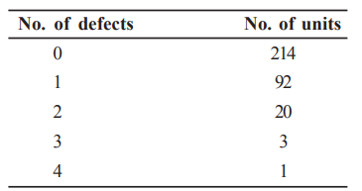
Fit a poisson distribution to the above given data.
Solution: The mean of the given frequency distribution is:
$$m=\frac{\left(0*214\right)+\left(1*92\right)+\left(2*20\right)+\left(3*3\right)+(4*1)}{214+92+20+3+1}=\frac{145}{330}=0.439$$
We can write
$$P\left(r\right)=\frac{{0.439}^{r}e^{-0.439}}{r!}$$
Substituting r = 0, 1, 2, 3, and 4, we get the probabilities for various values of r, as shown below:
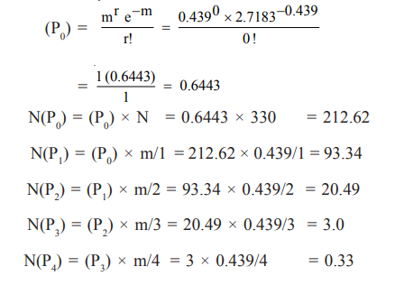
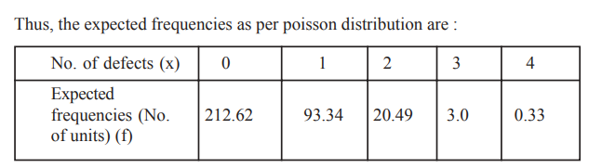

Practice Questions
- What are the features of binomial and poisson distributions?
- Suppose on an average 2% of electric bulbs manufactured by a company are defective. If they produce 100 bulbs in a day, what is the probability that 4 bulbs will have defects on that day?
- Four hundred car air-conditioners are inspected as they come off the production line and the number of defects per set is recorded below. Find the expected frequencies by assuming the poisson model.
No. of defects: 0 1 2 3 4 5
No. of ACs: 142 156 69 27 5 1

TEXT BOOKS
- T1 = H. K Dass, Higher Engineering Mathematics, S. Chand Publishers,3rd revised edition.2014.
- T2 = B.S. Grewal, Higher Engineering Mathematics, Khanna Publishers,42th ed.2013, New Delhi.
- T3= N. P. Bali and Manish Goyal, A textbook of engineering Mathematics, Laxmi Publications, Reprint 2008.

REFERENCE BOOKS
- R1=R. K. Jain and S. R. K. Lyenger, Advanced Engineering Mathematics ,3rd Edition Narosa Publishing House ,2004,New Delhi.
- R2 =B. V. Ramana Advanced Engineering Mathematics, McGrawHill, July2006, New Delhi.
- S.P.Gupta,StatisticalMethods,S.Chand&Sons,2017,NewDelhi,ISBN9789351610281Insiders’Guide

Video Lecture :
https://www.youtube.com/watch?v=c06FZ2Yq9rk

